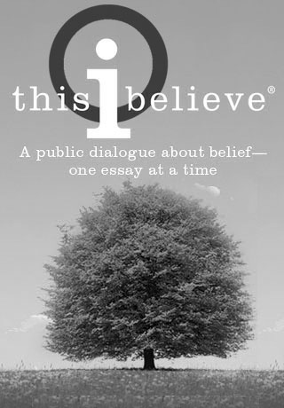
8th-GRADE READING SYLLABUS

Nome-Beltz Junior High School
8th-Grade Language Arts

2016 -2017 Ms. Teriscovkya Smith Room: 125A

Room: 125A 443-6161
tsmith@nomeschools.com web site:
http://teriscovkya smith.weebly.com

WELCOME! 8th-Grade Reading will give you a “toolbox” full of strategies that you can apply to any text to understand it, get a deeper meaning from it, and use that understanding to grow as a critical thinker. Throughout the year, you will learn how to:

- EVALUATE and ANALYZE literature across a range of themes through group and independent reading

- ENGAGE effectively in a range of group discussions about literature
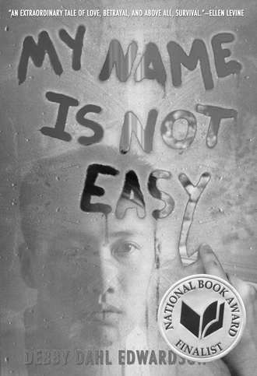
- PRESENT findings in a coherent manner with relevant evidence

- DEMONSTRATE command of language and its conventions

We will use the following texts to develop skills:
- My Name is Not Easy, by Debby Dahl Edwardson
- Night, by Elie Wiesel
- The Adventures of Huckleberry Finn, by Mark Twain
- Tree Girl, by Ben Mikaelsen
- The House on Mango Street, by Sandra Cisneros
- The Absolute True Diary of a Part-Time Indian, by Sherman Alexi
- The Outsiders, by S.E. Hinton

You are required to have the following materials for each class:
- Pen, pencil, and highlighter
- Required text and/or handouts as requested
- Eyewear: If you wear glasses for reading, use them! Often, the one barrier to success in a class has to do with your ability to see and focus effectively.

To determine your grade:

90-100 = A 80-89 = B 70 -79 = C 60-69 = D 59 and lower= F
Excellent! Great! Good Below standard Failing
We will adhere to the guidelines and policies of the Nome-Beltz Student Handbook, so please make sure you are familiar with its content. All course outcomes and objectives align with the Alaska State Standards for 8th-Grade Language Arts.

Your grade is based on the overall points for the following categories:
Participation (100 points everyday)
- 50 points for being in class on time and prepared
- 50 points every day for being actively engaged and respectful of peers
Projects and Presentations
Quizzes
Binder
Reading Journals
Free Book Reading Logs

What are Free Books and Reading Logs?
Reading outside of class and school is a very important part of becoming a better reader; practice, practice, and more practice will result in success! You are required to read books of your choice (Free Book) throughout the year in order to qualify for a specific letter grade (see chart below).

After a book is read, whether it is at home or at school (or both!), you will fill out a “Free Book Reading Log” to let me know what you know. I will track your pages throughout the year to determine what grade you should earn at the end of each quarter. All Free Book Reading Logs must be handed in by the due dates posted in Power School so keep your eyes peeled for our schedule! Please make sure you have a library card!!!

Page requirements for letter grade qualification are as follows:
- 400 pages or more per quarter = qualifies for an “A”
- 300 pages or more per quarter = qualifies for a “B”
- 200 pages or more per quarter = qualifies for a “C”

Please note: Reading a certain amount of pages does not automatically guarantee that letter grade. Earning points in the above categories in addition to reading will ensure your success. Your parent or guardian might have to sign for certain readings – more information on this later. Page requirements will increase spring semester!

Respect our community: It is important to recognize that we are a community of differing opinions, backgrounds, and beliefs. Sometimes, we will discuss various topics and we will occasionally disagree. But we can respect each other’s thoughts and ideas to promote an environment that is safe for exploration. This requires maturity and the willingness to look outside of ourselves and consider the views of others. This won’t be easy. It won’t happen overnight. We will all mess up. But we will grow as a community of learners and thinkers. I promise.

Remember to: Agree to disagree

COMPLETE YOUR WORK! If you use class time wisely and stay on task with reading at home, you will be fine. All assignments will be posted on Power School so if you know you will be out, you can easily look things up to avoid falling behind. You can also make use of Tutoring opportunities to complete late or missing assignments. Cheating is never an option and work that is copied or plagiarized will receive a zero with no 2nd-chance for revising – so do your best, talk to me about your concerns, and rock this year!

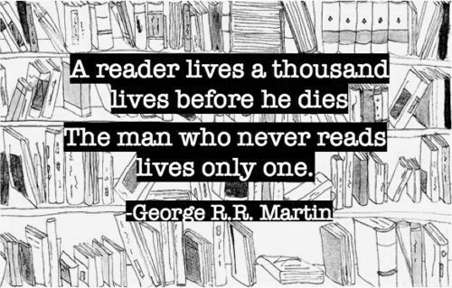
Fall 2016 8th-Grade Reading

(100 pts): Reading Syllabus Contract

Dear Parents and Guardians:

Please review the following 8th-Grade Reading Syllabus. We covered all the specifics in class, students filled in the blanks, and they should be able to explain how things work to you. Once everyone understands the expectations, sign the appropriate spaces below. Students should return the ENTIRE handout to Ms. Smith by:

DUE: _______________________________________

I am looking forward to a great year of writing with you!

Warmly,
Teriscovkya Smith
8th-Grade Language Arts
tsmith@nomeschools.com

PS: This is the EASIEST 100 points student will earn all year – please sign and return!

STUDENT: I have read and understand the class description, grading, and expectations. I understand what is required for me to succeed in this class. I understand that my progress will be available on PowerSchool and updated weekly and that I may see Ms. Smith during office hours for assistance.

______________________________ Date: _____________ ___________________________________
Print name here Sign name here

PARENT/GUARDIAN: I have read and understand the class description, grading and expectations. I understand what my child is required to do to excel and succeed in this class and that I might need to periodically sign off for reading and other activities. I understand that academic progress will be available on PowerSchool and updated weekly.

______________________________ Date: _____________ ___________________________________
Print name here Sign name here

